Setup a WordPress Site

A step by step manual in setting up a WordPress site

Bath, Anneka

ENG 3303: Technical Writing

|  |  |
| --- | --- |
| http://www.pngall.com/wp-content/uploads/2016/05/WordPress-Logo-Free-Download-PNG.pnghttp://static.internetblog.org.uk/files/11_logo.png  Setup a WordPress Site | How to Build a website using WordPress and 1&1 Hosting  A quick instruction guide to building a professional website using 1&1hosting and the WordPress platform.  Griffith, Anneka  ENG 3303: Technical Writing |

Contents

Introduction 3

Setting up your Host 3

1. Setting up a domain: 3

2. Hosting set up overview: 5

3. Setting up WordPress to your server: 6

Setting up your WordPress Site 7

1. Logging Into WordPress 7

2. WordPress Dashboard 8

3. WordPress 1&1 WP Wizard tool 9

|  |
| --- |
| How to setup a website using WordPress and 1&1 Hosting |

|  |  |
| --- | --- |
|  | This instruction manual is to help people create their first WordPress site and can be used as a reference tool to the setup process. It’ll help users set up a host for their website and go over the basic tools to build and maintain a WordPress site.  WordPress is an extensive tool that uses many plugins, widgets, and themes. This material will touch on these tools, but not go into extensive details. It’s meant to get the user started. For it is up to the site administrator to learn and explore the tools that WordPress and hosting provide. |

# Introduction

SETUP A WORDPRESS SITE

**Why build a WordPress site?**

WordPress is a robust tool that helps users build an easy to update and maintain site that is relatively cheap. Once the site is build and the framework set in place it’s easy to update the content. And even change the entire appearance of a website without knowing CSS, PHP, and even HTML.

**Why do you need a host?**

All websites have a host. Sites require a server to store and maintain a website’s content and design information over the internet. Some sites provide free hosting and others require payment. Free hosting limits the user’s ability to control their site information and layout. For purposes of this manual we well create our site using <https://www.1and1.com>. 1&1 is a good hosting site that provides relatively cheap hosting and free domain names.

This manual will help walk your through the hard part of setting up and getting started with WordPress.

# Setting up your Host

The first thing any site administrator does is choose a hosting company to build the website through. Each hosting company has servers that load your websites information to the web. Every website needs one and for this manual we are using <https://www.1and1.com>. There are many other host companies out there, each have different platforms and site specifications that meet WordPress requirements (<https://wordpress.org/about/requirements/>). 1&1 is just a preferred platform based off price and usability.

1. Setting up a domain: Go to <https://www.1and1.com>. Once you at the site you will find on the landing page a section to create a domain name and check to see if it is available. See Figure 1 below.

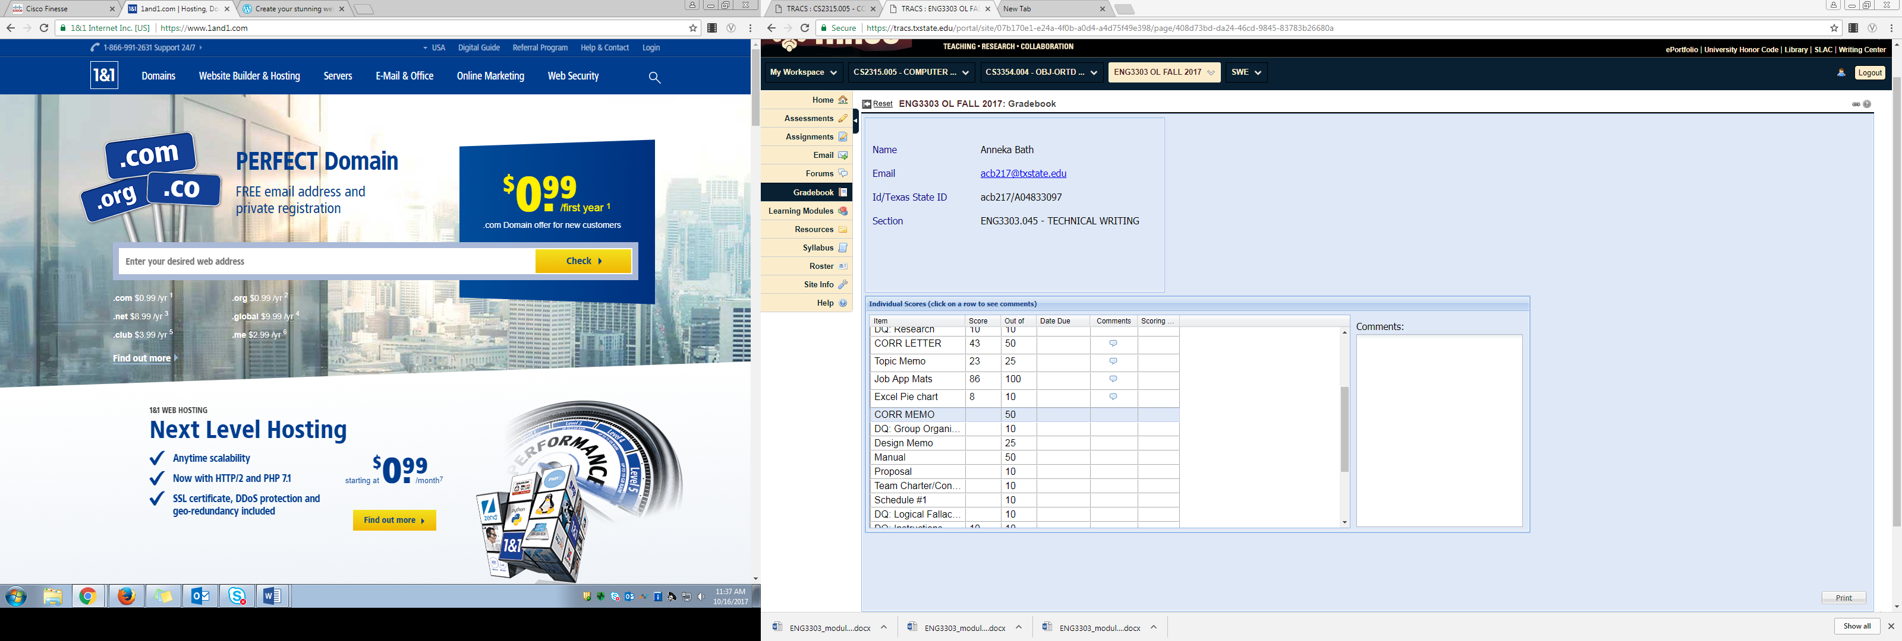

Figure : landing page create a domain field

1&1 will offer many options for your domain name, but in most cases users and admins are looking for a “.com” address. So, choose something appropriate for your site needs.

  *As a basic rule of thumb extensions addresses are associated as the following:*

* *.com = businesses*
* *.net = network providers / hosting companies*
* *.org = not for profit*

Once you have selected and appropriate site name. Choose a hosting plan that’s right for your site. For this manual, we’ll assume you choose the basic plan for a basic formal company or a portfolio site with a “.com” address. The basic package, as of October 16, 2017, is $11.88 for the first year of service. Purchase the domain and service package, and set up your account information.

  *Note this is a WordPress addon you can buy at check out. You do not need to purchase this. See figure 2 below.*

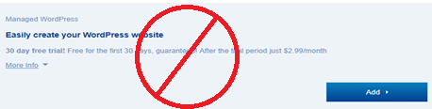*Figure 2: WordPress addon dialog box. Don’t select this addon. WordPress is a free download.*

Once you’ve selected the create a new account button, you’ll be promoted to the billing information. The first Question asks if this is a business or company. Select your appropriate option. See Figure 3 below.

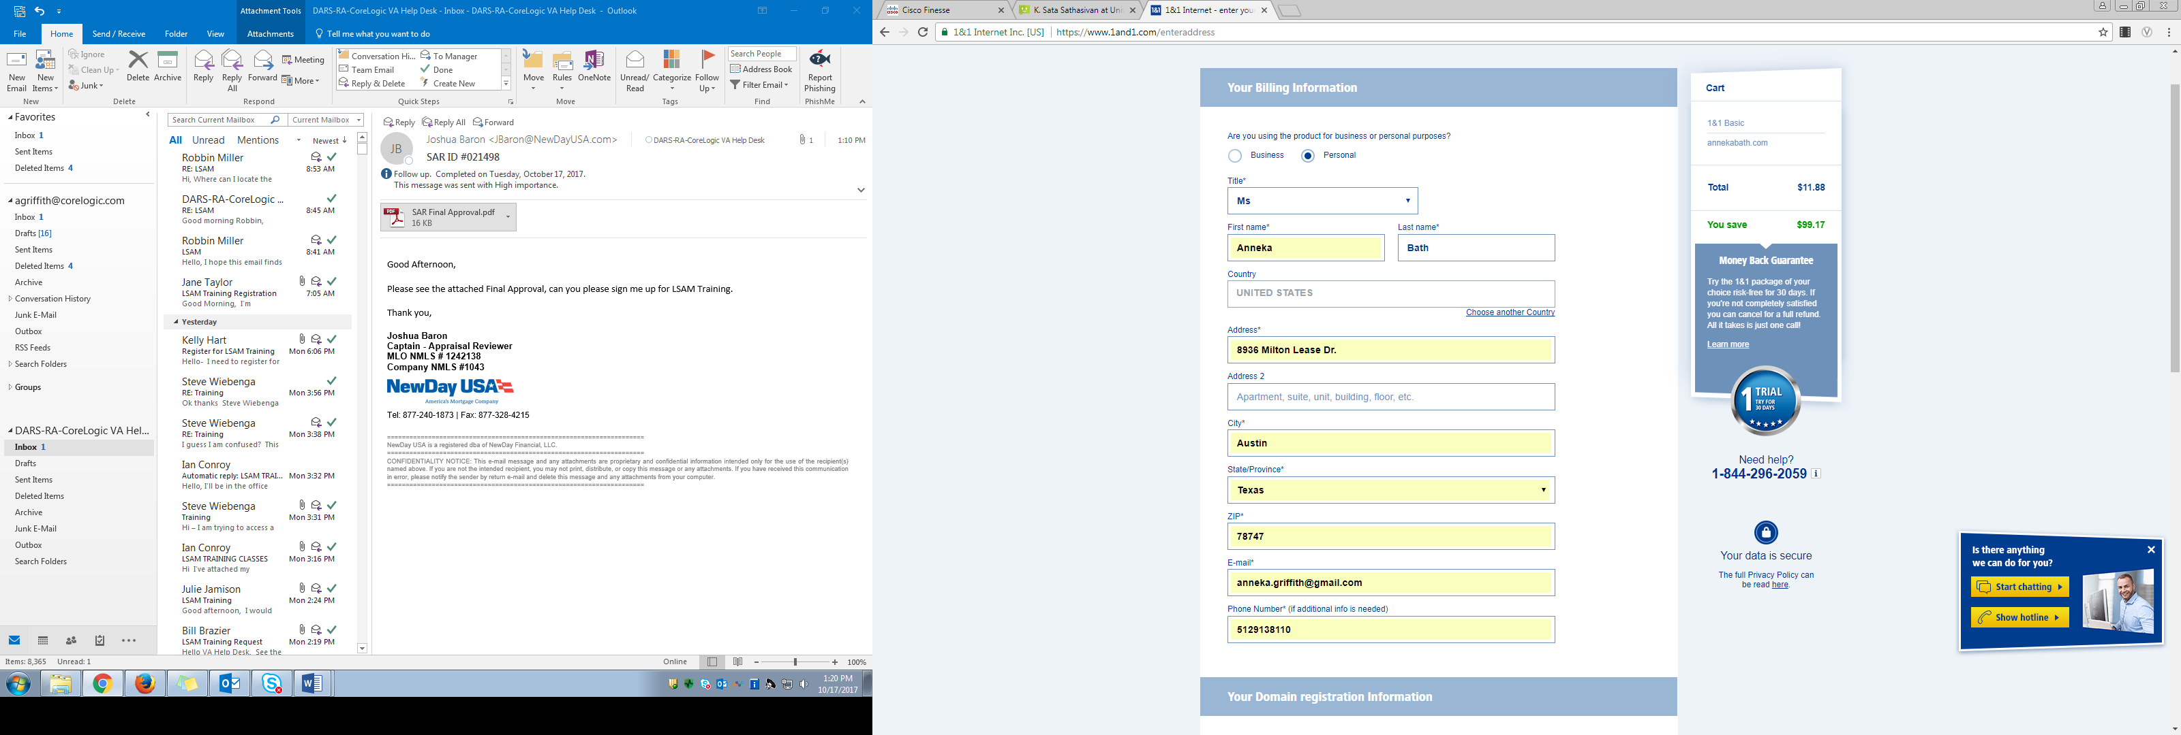

Figure : First question on site’s account creation asking if you want to create a business or a personal site.

Once you’ve completed the Billing and account information you get a screen showing your order was completed. The Control Panel will take a few moments to populate. See Figure 4 below.

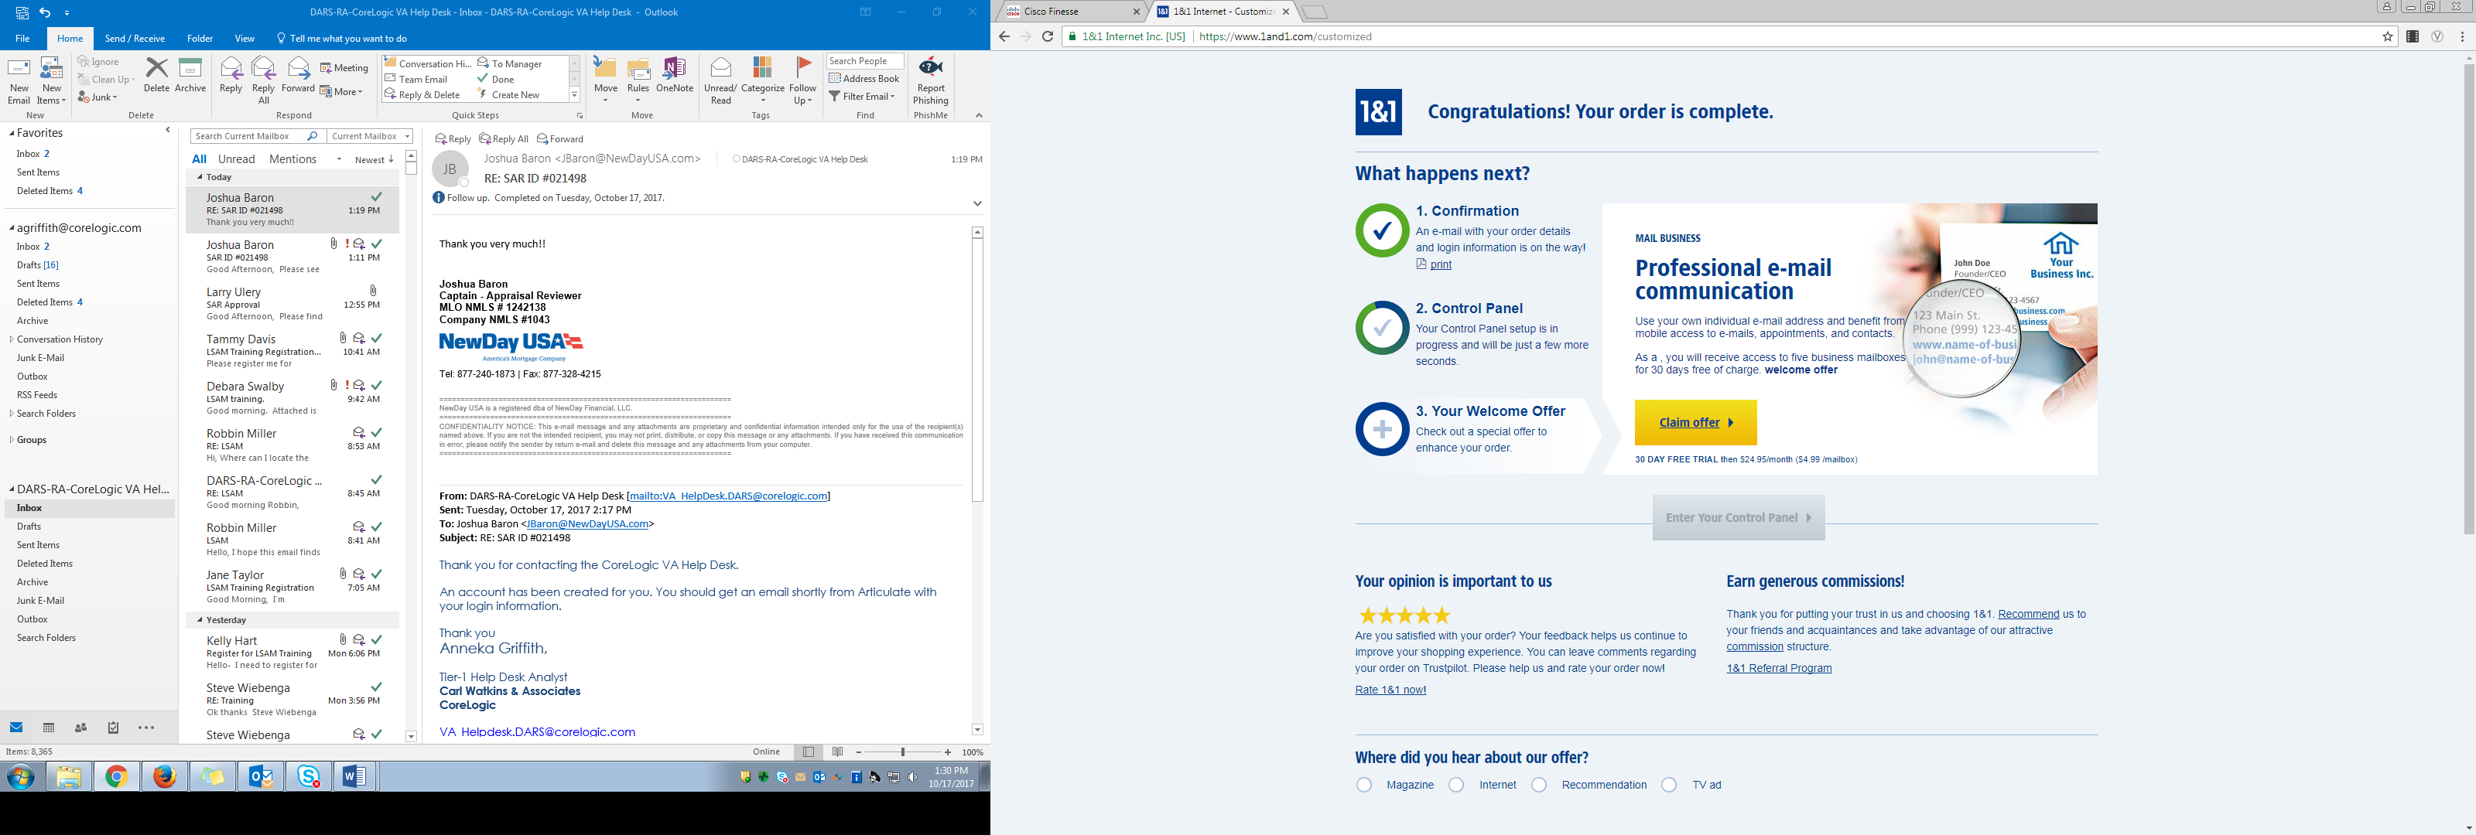

Figure : Order Completion Page

1. Hosting set up overview: Once you’ve finished purchasing your service and the Control Panel is finished populating you will find and click on the button allowing you to “Enter Your Control Panel”. See figure 5 below.

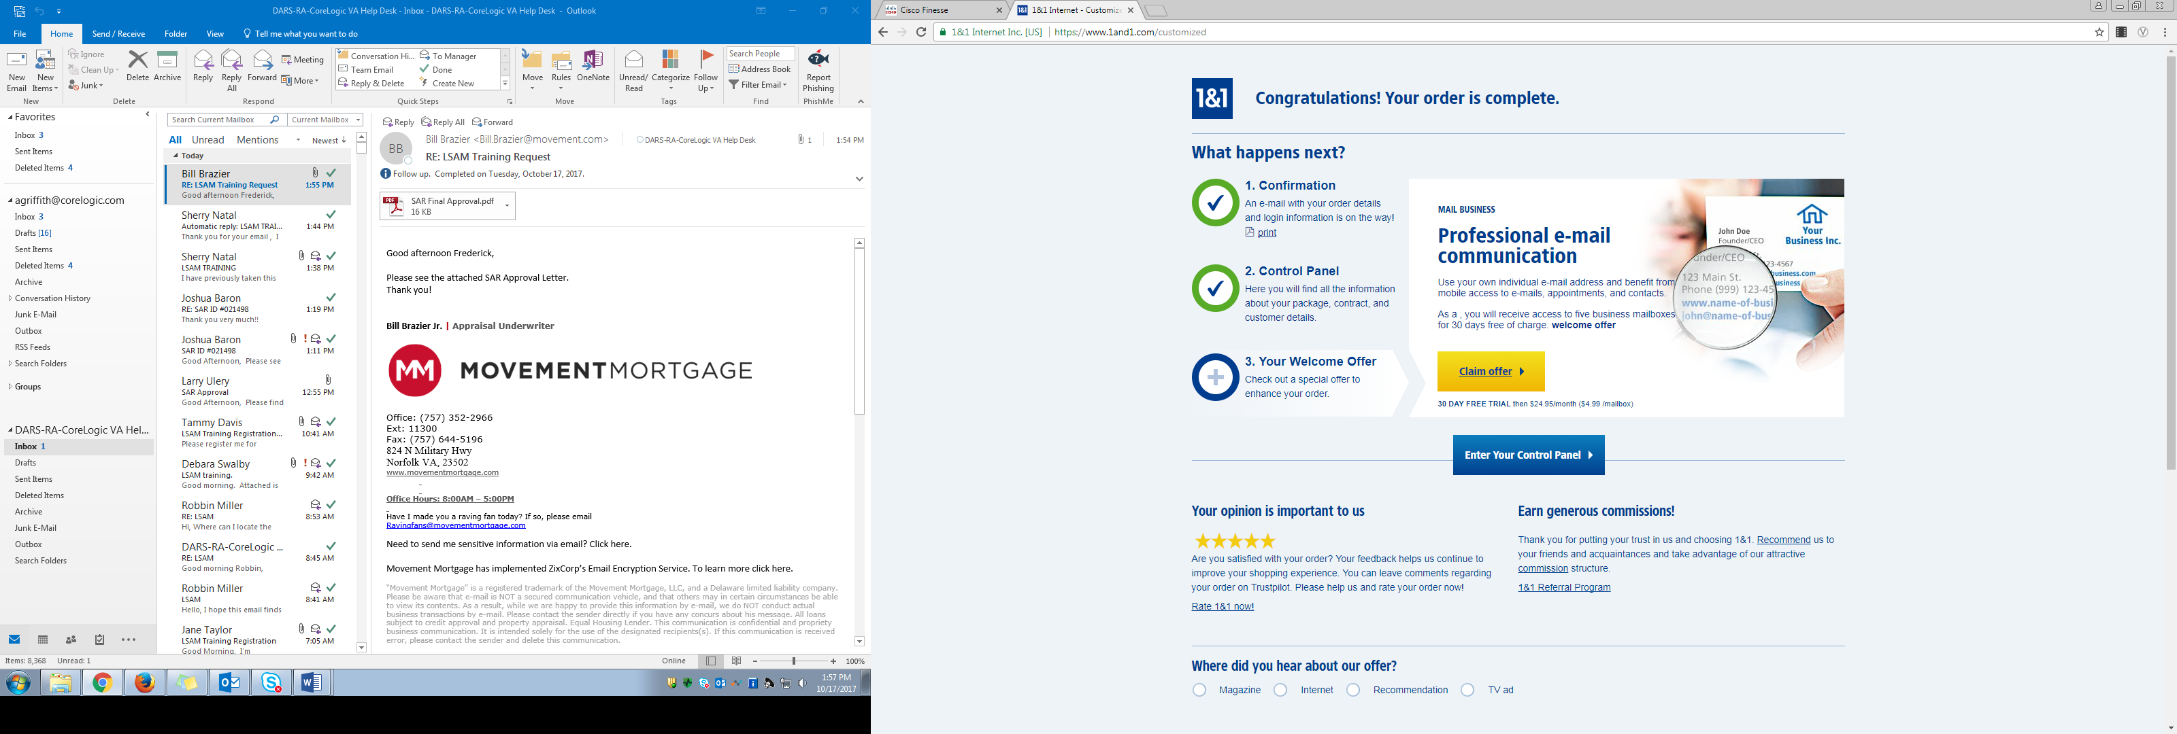

Figure : Enter Control Panel Button. Can be found mid screen on the completion page.

You should then have a page that looks like Figure 6 below. If you get an error just simply use the login link on the top right of the page. You can easily login to your account by entering your site URL, In my case it’s “annekabath.com”, and your account password.

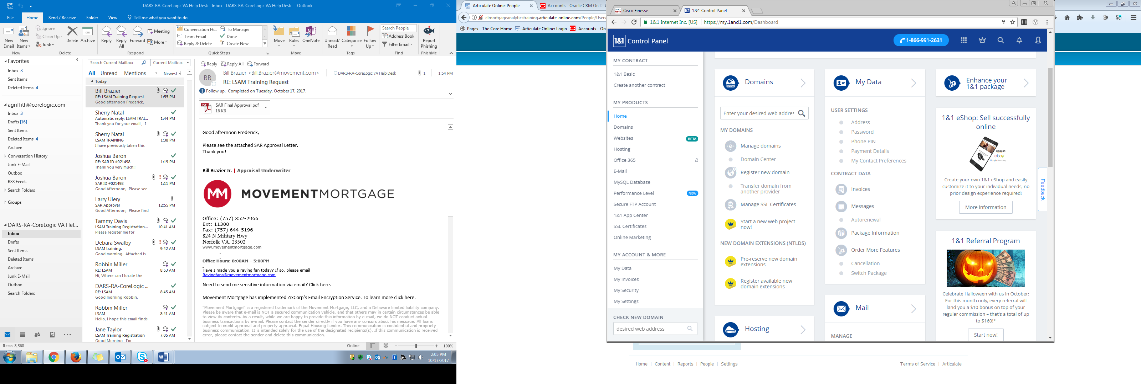*Figure 6: Control Panel Screen*After creating your account you’ll receive emails confirming your order and outlining the hosting contract. These contracts outline rules that a user must follow on website content. Most of it outlines liabilities, and parts of it outline rules on website regulations such as rules on pornography, and gambling on the user’s site and or server. Be sure to read through these if you are unclear about site regulations, but as a good rule of thumb read through this contract.   
  
The last email you will receive is an invitation to set up your domain. You’ll have a limited window of 14 days to confirm and set up this domain. Otherwise you’ll need to resend the email, which can be done through the “Domains” section of your control Panel. See Figure 6 above. Once you receive this email, open the email and click the “Set Up Domain” button in the email. This will lead you to a login page. Once you’re logged in the site will send you to side navigation “1&1 Basic” page. See Figure 7 below.

1. Setting up WordPress to your server: As you Scroll through the 1&1 Basic page you will notice a section for WordPress, select the “Get Started” button. This link will have you set up a site title and then a WordPress admin account.

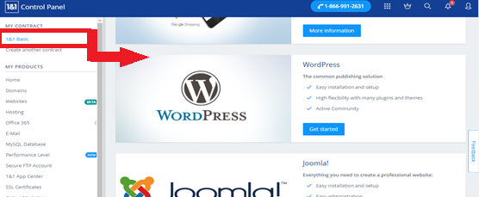Figure : 1&1 Basic page note the WordPress section and get started button.

Once you are finished creating the Admin account and read through and accepting WordPress’s terms, you’re lead to the select and installation type page and you’re going to select the free installation on the right. See Figure 8 below.

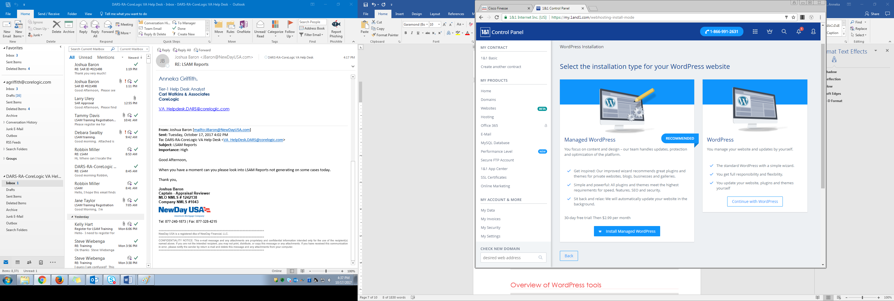Figure : Select the right option the free installation of WordPress.

Once you’ve selected the free option the next page is will provide you with a drop-down menu to “Select a domain from your 1&1 package:” Choose your URL from the list. For example, mine is annkebath.com. once you’ve done this click the “Assign” button. You’ll then be brought to the App Center and you’ll see WordPress is set up and ready to use. See Figure 9 below.

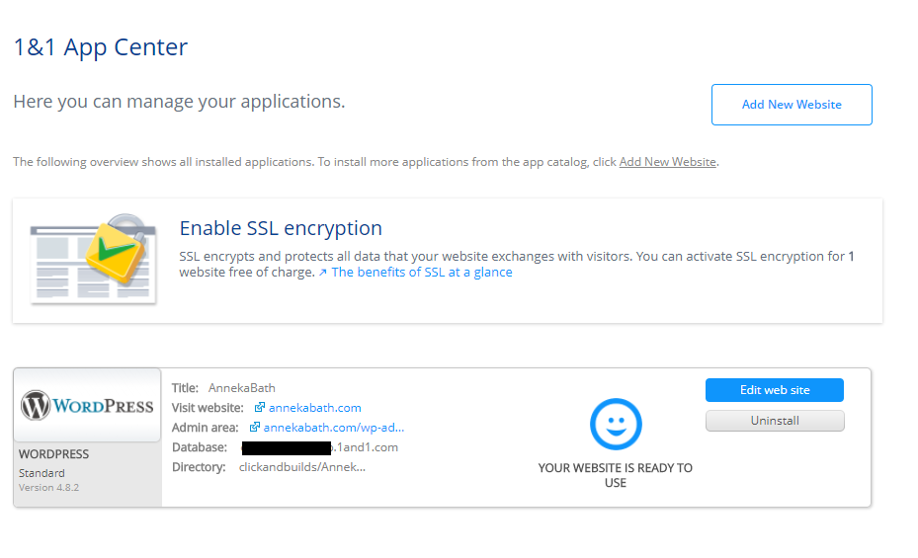Figure : App Center shows that Wordpress is installed and read to use.

|  |  |
| --- | --- |
|  | Note: At this time, you can set up the SSL encryption. For this manual, we are not setting it up because it isn’t necessary for our site requirements.   SSL is necessary for if you are building a shopping cart. If you are going to allow purchases, or lets visitors create an account on your site go ahead and set that up. However, for this manual we are not setting either of these functions. |

# Setting up your WordPress Site

There are so many tools that WordPress has built in. 1&1 hosting has some brilliant built-in applications that really make it helpful to get started in WordPress. The next few steps will help guide you through the platform and setup for success.

1. Logging Into WordPress: I know this sound straight forward, but being a first-time user, this can be a tricky step. If you refer to Figure 9 above you’ll see a link to edit website this will get you to the login page where you can type in your WordPress Admin information you set up earlier. I would bookmark this page so it’ll be easy to navigate to at a later date. This is the page you’ll use every time you want to login and make edits to the WordPress site. See Figure 10 below.

If you forget how to get to the login in page, or you are using another computer. You can always look up the login URL from 1&1 app Center. If you refer to Figure 9 above you’ll see a field called “Admin Area”, this is the URL you use to access the WordPress login, however you can always use the “Edit web site” button to get you to the login screen.

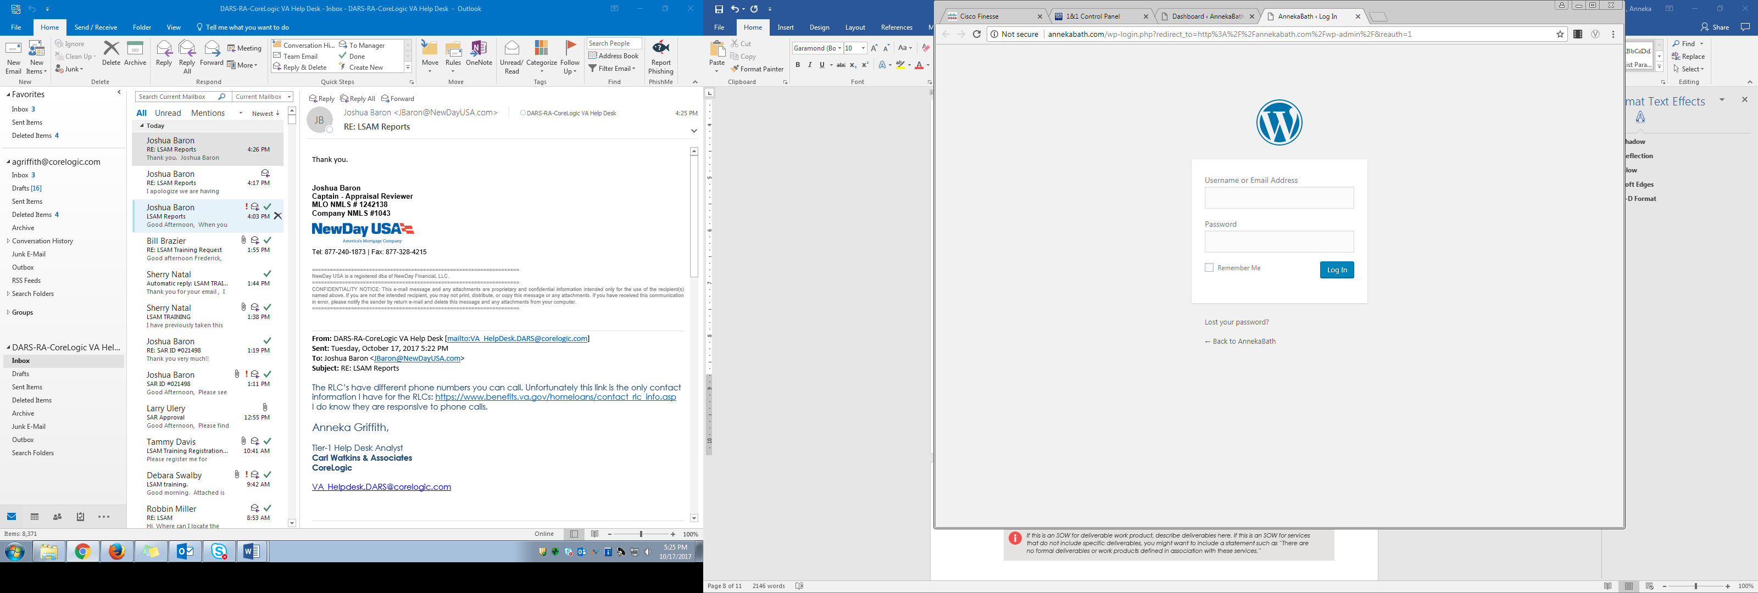

Figure : WordPress admin login page

1. WordPress Dashboard: Now you’re logged into WordPress and the first screen you see is your Dashboard. See Figure 11 Below

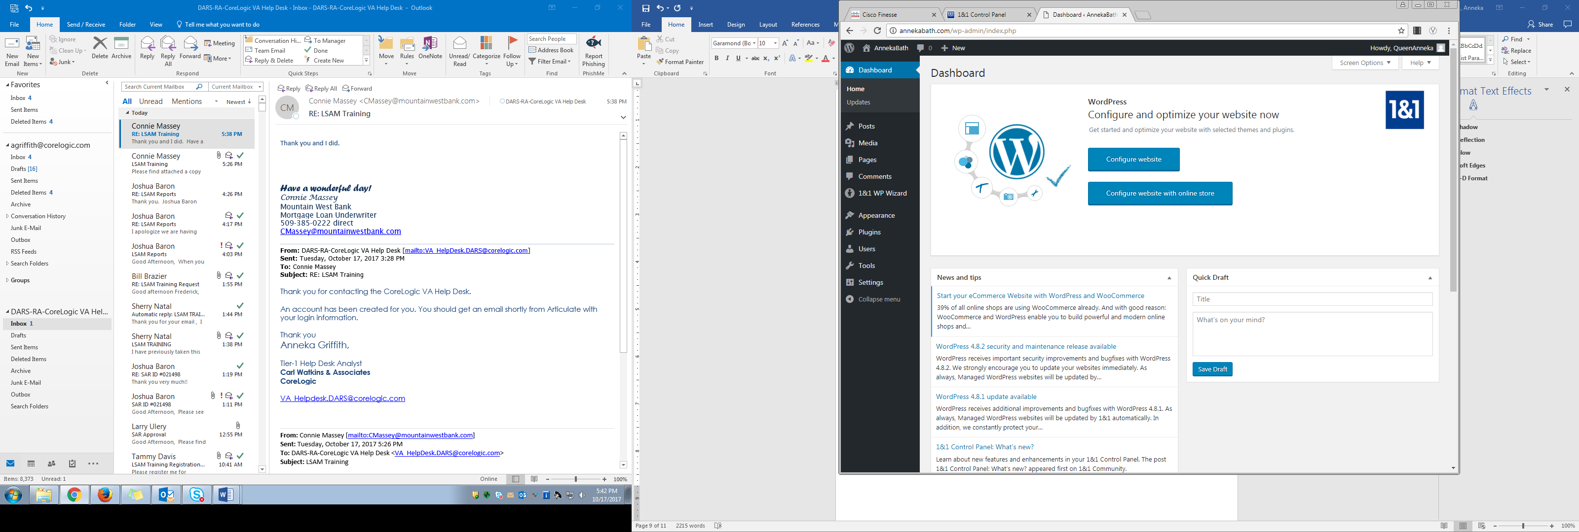

*Figure 11: WordPress Dashboard screen*

Now you can see the WordPress platform has many tools which are included in the side navigation bar and the top navigation bar. See Figure 11 above. If you select the icon with the small house on the top navigation bar a drop down appears that allows you to “visit your site”. Notice there is already content generated in your site. See Figure 12 below.

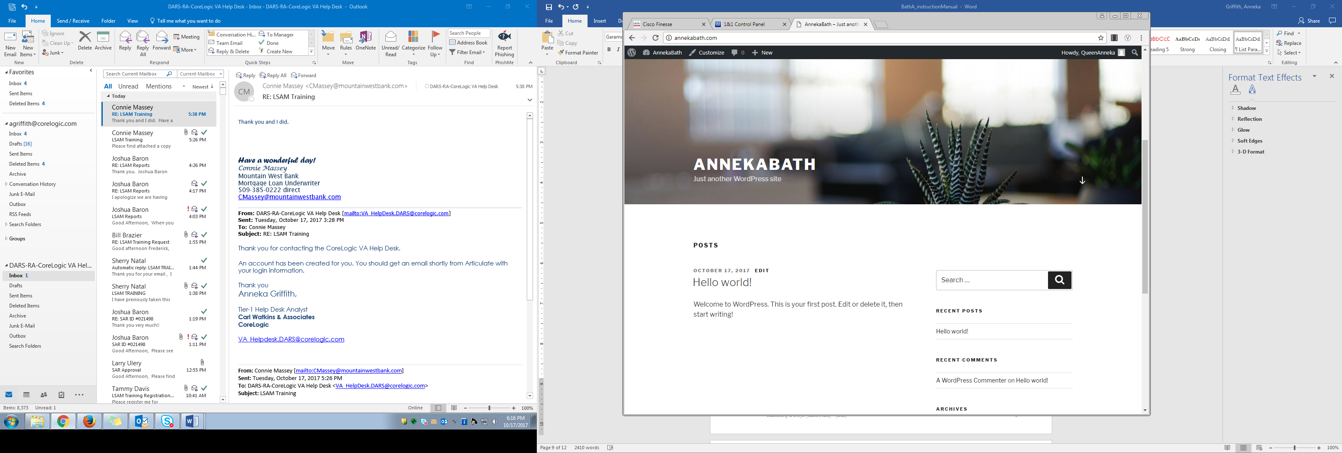  
Figure : Website home page

1. WordPress 1&1 WP Wizard tool: Refer to Figure 13 below. Notice the “1&1 WP Wizard” side navigation link. Selecting this will bring you to a page where you can easily set up the type of site you need. These options are Company, Blog, Online Store, Gallery, and Personal. Choose whichever meets your needs. The tool will walk you through the steps and even provide recommendations for plugins.   
     
   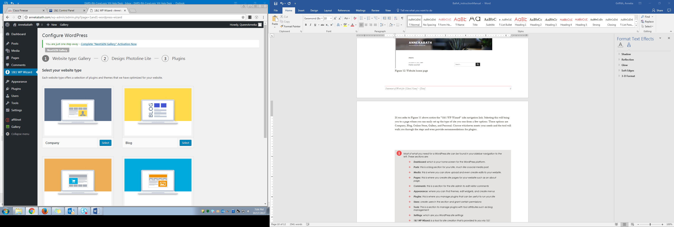

*Figure 13: 1&1 WP Wizard tool*

Now you’re all set-up to customize your website and add content. Explore the tools the WordPress platform has to offer, and be creative.

|  |  |
| --- | --- |
|  | Most of what you need for a WordPress site can be found in your sidebar navigation to the left. These sections are:   * **Dashboard:** which is your home screen for the WordPress platform. * **Posts**: this is a blog section for your site, much like a social media post. * **Media**: this is where you can store upload and even create edits to your website. * **Pages**: this is where you create site pages for your website such as an about page. * **Comments**: this is a section for the site admin to edit visitor comments * **Appearance**: where you can find themes, customize themes, edit widgets, and create menus * **Plugins**: this is where you manage plugins that can be useful to run your site * **Users**: create users in the section and grant certain permissions * **Tools**: This is a section to manage plugins with tool attributes such as blog management * **Settings**: which are you WordPress site settings * **1&1 WP Wizard:** is a tool for site creation that is provided to you via 1&1 |